 | VINS D’ALSACE JOSMEYER  Wine made from organically and  biodynamically grown grapes

PINOT AUXERROIS “H” Vielles Vignes 2015  THE RANGE  Range : Grand Cru  VINES | 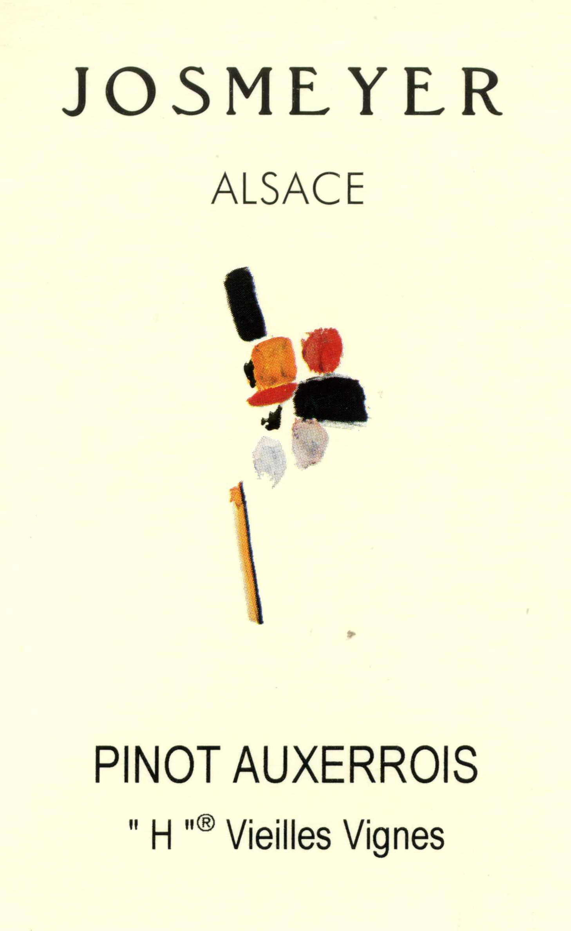

Terroir : The soil of the 360 meter high slope which dominates this vineyard is essentially a mixture of limestone from the Vosges, chalky marl (14% active) and layers of red, brown, green and beige sediment hundreds of meters thick. The mother rock is of an orange - yellow hue. Dating as far back as the Jurassic period the elements vary in density from very fine to very course. The Ph factor is within 7.8 to 8.3. This Grand Cru is 130.95 acres (53,02 Ha) of vines. The combined calcareous and marl soils tend to produce rich full bodied wines. In their youth they have an untamed character, reminiscent of the vineyard's name - "stallion". They slowly mature to astonishing aromatics and fabulous richness.

Age of vines : 60 years

Grape Variety : 100 % Pinot Auxerrois

THE WINE

Sugar level : 0 g /l  Alcohol level : 13,5 % / volume | Acidity level : 5.4 g /litre (tartaric acidity )  Yields : 40 hl / ha

Name : Planted in the heart of the HENGST vineyard, this wine is not authorised to have the Grand Cru appellation. The "H" refers to the HENGST.

Vinification : All grapes are hand - picked and whole-bunch pressed very slowly and gently in pneumatic presses over 5-8 hours to give a clean must and a beneficial amount of skin contact. Transferred to thermo-regulated stainless steel tanks the juice then begin a natural fermentation using only its own natural yeast. After one week, depending the rhythm of the fermentation, the wine is pumped in our old centenary oak cask where it finish its fermentation. After a maturing on fine lies from 4 to 8 months, the wine is filtered and bottled before the heat of summer to preserve the natural carbonic gas (a natural anti-oxidant).

Wine Tasting : The 2015 Pinot Auxerrois H Vieilles Vignes is sourced in the marl and limestone soils of the Hengst and comes from vines planted at the end of the 1960s. The wine opens with a clear, fresh and elegant bouquet with limestone and lemon flavors. Full-bodied, creamy and elegant on the palate, this an elegant and intense Pinot with a ripe and mineral acidity (no malolactic had been done here), as well as a long and pretty intense finish. Anticipated maturity: 2017 - 2024.
ROBERT PARKER WINE ADVOCATE - March 2017

Food Pairings : Terrines of fish, scallops, sweetbread, lobster, blanquette, soufflés, vegetables, poultry, pies, creamy cheeses.

